
KFGSC, Tiptur

DEPARTMENT OF BACHELOR OF COMPUTER APPLICATIONS

KALPATARU FIRST GRADE SCIENCE COLLEGE

TIPTUR – 572201

(A UNIT OF KALPATARU VIDYA SAMSTHE ®)

Affilated to Tumkur University and Reaccredited with A grade from NAAC

PROJECT

REPORT

ON

House Price Prediction using Regression

House Price Prediction using Regression

A Project report submitted in partial fulfilment of the requirements for the award of Degree of

BACHELOR OF COMPUTER APPLICATIONS

IN

DATA SCIENCE

Submitted by

Team members name

II BCA (Data science)

4th semester

U11KT24S0163

Under the esteemed guidance of

Ravikiran S J ,MCA, SOC Analyst and Omkar K P, MCA,Python Developer

Department of BCA


KFGSC, Tiptur

DEPARTMENT OF BACHELOR OF COMPUTER APPLICATIONS

KALPATARU FIRST GRADE SCIENCE COLLEGE

TIPTUR – 572201

(A UNIT OF KALPATARU VIDYA SAMSTHE ®)

Affilated to Tumkur University and Reaccredited with A grade from NAAC

Department of Bachelor of Computer Applications

KALPATARU FIRST GRADE SCIENCE COLLEGE

(A Unit of Kalpataru Vidya Samsthe ®)

Affiliated to Tumkur University and Reaccredited with A grade from NAAC

Tiptur (t),Tumkur (d) – 572201


CERTIFICATE
This is to certify that the project work entitled "[Insert Project Title Here]" is a bonafide work carried out by:
- [Insert Team Member Name 1] ([USN/Register No])
- [Insert Team Member Name 2] ([USN/Register No])
- [Insert Team Member Name 3] ([USN/Register No])
- [Insert Team Member Name 4] ([USN/Register No])
The project is submitted in partial fulfillment of the requirements for the award of the degree of Bachelor of Computer Applications (BCA) in Data Science and represents their original work in the field of Machine Learning.

Project guide :

Ravikiran S J

MCA, SOC Analyst

Omkar K P

MCA, Python Developer

ACKNOWLEDGEMENT
I would like to express my sincere gratitude to my project guides, Mr. Ravikiran S J and Mr. Omkar K P, for their valuable guidance, continuous support, and encouragement throughout the successful completion of our project titled "[Insert Project Title Here]". Their technical insights, constructive suggestions, and timely feedback played a crucial role in shaping this work and enhancing our understanding of Machine Learning.
I also take this opportunity to state that this project has been prepared by our team as part of the Bachelor of Computer Applications (BCA) in Data Science curriculum. This project provided us with an excellent opportunity to apply theoretical concepts to practical implementation and gain hands-on experience in the field of Machine Learning.
I am thankful to all the faculty members for providing the necessary academic support and resources during the course of this project. I would also like to acknowledge our friends and well-wishers who extended their help, motivation, and cooperation directly or indirectly, contributing to the successful completion of this work.

Team Members:

CONTENTS
1. Abstract ------------------------------------------------------------------------ 6
2. Overview ----------------------------------------------------------------------- 7
3. Introduction --------------------------------------------------------------------- 8
4. Problem Statement -------------------------------------------------------------- 8
5. Objectives of the Project ------------------------------------------------------- 9
6. Scope of the Project ------------------------------------------------------------- 9
7. Literature Review ----------------------------------------------------------------
8. Dataset Description ---------------------------------------------------------------
8.1 ----------------------------------------------------------------------------------
9. Methodology ----------------------------------------------------------------------
10. Data Preprocessing ---------------------------------------------------------------
11. Exploratory Data Analysis (EDA) ----------------------------------------------
12. Regression Models Used ---------------------------------------------------------
13. Model Training and Testing -----------------------------------------------------
14. Performance Evaluation Metrics -------------------------------------------------
15. Results and Discussion ------------------------------------------------------------
16. Advantages of the System --------------------------------------------------------
17. Limitations of the System ---------------------------------------------------------
18. Applications of House Price Prediction -------------------------------------------
19. Conclusion -----------------------------------------------------------------------------
20. Future Enhancements ------------------------------------------------------------------
21. References --------------------------------------------------------------------------------

ABSTRACT
House price prediction is an important real-world problem in the real estate domain, where accurate price estimation helps buyers, sellers, and investors make informed decisions. This mini project titled “House Price Prediction using Regression” focuses on predicting house prices by applying machine learning regression techniques on historical housing data.
The project involves collecting a structured dataset containing various attributes such as house size, number of bedrooms, number of bathrooms, location features, and other relevant factors that influence property prices. The collected data is preprocessed to handle missing values, remove inconsistencies, and normalize numerical features. Exploratory Data Analysis (EDA) is performed to understand data distribution, identify correlations, and visualize important patterns affecting house prices.
Regression algorithms such as Linear Regression and other suitable regression models are implemented using Python and machine learning libraries like Pandas, NumPy, Matplotlib, and Scikit-learn. The dataset is divided into training and testing sets to evaluate model performance. Evaluation metrics such as Mean Absolute Error (MAE), Mean Squared Error (MSE), and R-squared score are used to measure prediction accuracy.
The results demonstrate that regression models can effectively learn the relationship between housing features and prices, producing reasonably accurate predictions. This project provides practical exposure to supervised learning, regression analysis, and predictive modeling while strengthening the understanding of data preprocessing and model evaluation techniques. The study highlights the usefulness of machine learning in solving real-world data science problems.

House Price Prediction using Regression

Mini Project Report (BCA – Data Science)
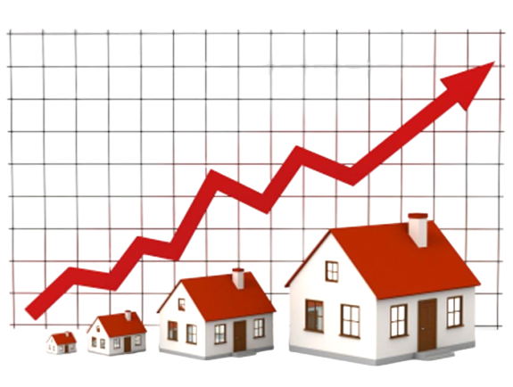

House Price Prediction using Regression

Project Overview
- This project focuses on predicting house prices using regression techniques in Machine Learning.
- Housing price prediction is a classic supervised learning problem where historical data is used to model the relationship between property features and market value.
- The model analyzes key factors such as location, size, number of rooms, and other attributes that influence house prices.
- Regression algorithms are applied to learn patterns from the dataset and estimate prices for unseen data.
- The project demonstrates the complete machine learning workflow, including data preprocessing, exploratory data analysis, model training, and evaluation.
- The objective is to build an accurate and reliable predictive model that assists in data-driven decision-making in the real estate domain.
- This study highlights the practical application of regression models and their importance in solving real-world prediction problems.

Introduction
The rapid growth of the real estate sector has led to an increased demand for accurate and reliable house price estimation. Property prices are influenced by multiple factors such as area of the house, number of bedrooms and bathrooms, construction year, location, condition of the property, and availability of facilities like a garage. Traditionally, house price estimation is performed manually by real estate experts based on experience and market trends. However, such methods are often time-consuming, subjective, and prone to inaccuracies.
With the advancement of data science and machine learning technologies, it has become possible to analyze large volumes of historical data and extract meaningful patterns for prediction. Regression techniques in Machine Learning are widely used when the target variable is continuous in nature, such as house prices. These techniques learn the relationship between independent variables (house features) and the dependent variable (price) to make accurate predictions.
In this mini project, a house price prediction system is developed using Linear Regression, one of the fundamental regression algorithms. The project is implemented using Python programming language in a Jupyter Notebook environment. Python libraries such as Pandas and NumPy are used for data manipulation, Matplotlib and Seaborn are used for visualization, and Scikit-learn is used for model building and evaluation.
The project involves important stages such as data preprocessing, exploratory data analysis, feature encoding, model training, testing, and performance evaluation. By implementing this project, practical knowledge of Machine Learning concepts is gained, and theoretical understanding is reinforced through real-world application. This mini project serves as a strong academic foundation for understanding predictive modeling in the Bachelor of Computer Applications (BCA) in Data Science curriculum.

Problem Statement
The real estate market is highly dynamic, and house prices depend on a combination of multiple factors such as size of the property, number of rooms, construction year, location, condition of the house, and availability of amenities. Estimating house prices manually using traditional methods is often inefficient, time-consuming, and subjective, leading to inaccurate pricing decisions.
With the availability of large volumes of housing data, there is a need for an automated and data-driven approach that can analyze historical property data and accurately predict house prices. The challenge lies in processing heterogeneous data, handling categorical and numerical features, and selecting an appropriate Machine Learning model that can generalize well to unseen data.
Therefore, the problem addressed in this mini project is to design and implement a Machine Learning-based house price prediction system using regression techniques, which can accurately estimate house prices based on given input features. The system should perform data preprocessing, exploratory data analysis, model training, and evaluation to ensure reliable and meaningful predictions.

Objectives of the Project
The main objective of this mini project is to design and implement a Machine Learning model that can accurately predict house prices using regression techniques. The specific objectives of the project are as follows:
- To study and understand the fundamentals of regression in Machine Learning
- To collect and analyze historical housing data for price prediction
- To perform data preprocessing such as handling missing values, encoding categorical variables, and feature scaling
- To carry out exploratory data analysis to identify patterns and relationships between house features and prices
- To implement a Linear Regression model using Python and Scikit-learn
- To train and test the model using appropriate data splitting techniques
- To evaluate the performance of the model using standard regression metrics such as MAE, MSE, RMSE, and R² score
- To identify the most influential factors affecting house prices
- To gain practical exposure to Python, Jupyter Notebook, and Machine Learning tools

Scope of the Project
The scope of this mini project involves the application of Machine Learning regression techniques to predict house prices based on historical data. The project focuses on building a supervised learning model where the relationship between independent variables (house features) and the dependent variable (house price) is learned using Linear Regression.
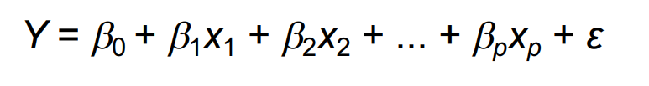
In this project, the house price prediction problem is mathematically modeled using the linear regression equation:

The project scope includes essential Machine Learning stages such as data preprocessing, feature encoding, feature scaling, model training, testing, and performance evaluation using error metrics like Mean Absolute Error (MAE), Mean Squared Error (MSE), Root Mean Squared Error (RMSE), and the R² score.
The system is developed using Python in a Jupyter Notebook environment and utilizes standard Machine Learning libraries such as Scikit-learn. The project demonstrates how supervised learning models can be applied to real-world prediction problems in a controlled academic setting.
However, the scope of this project is limited to linear relationships between features and house prices and is constrained by the size and quality of the dataset used. Advanced Machine Learning models, real-time data integration, and external economic factors are considered outside the scope of this mini project.

Dataset Description
The dataset used in this mini project consists of 2000 records related to residential properties and is used to train and evaluate the house price prediction model. Each record represents a single house with multiple attributes that influence its market price. The dataset includes both numerical and categorical features, making it suitable for applying supervised Machine Learning regression techniques.
The target variable (dependent variable) in this dataset is Price, which represents the selling price of the house. The remaining attributes act as independent variables (features) used to predict the house price.

Dataset Attributes
- Id: Unique identification number for each house
- Area: Total built-up area of the house measured in square feet
- Bedrooms: Number of bedrooms in the house
- Bathrooms: Number of bathrooms in the house
- Floors: Number of floors in the building
- YearBuilt: Year in which the house was constructed
- Location: Geographical location of the house (Urban, Suburban, Rural)
- Condition: Overall condition of the house (Excellent, Good, Fair, Poor)
- Garage: Availability of garage facility (Yes or No)
- Price: Selling price of the house (target variable)
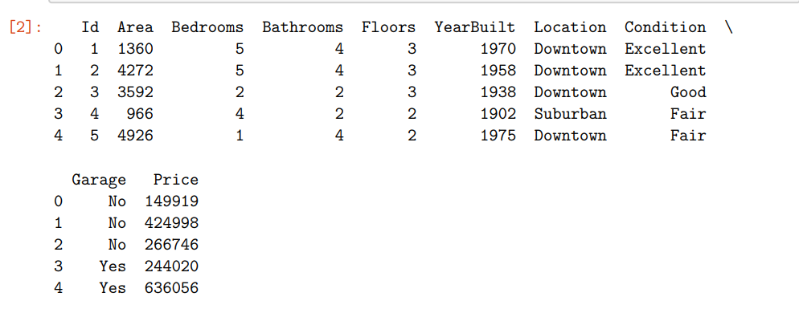

Machine Learning Perspective
From a Machine Learning point of view, this dataset represents a supervised learning problem, where labeled data is available and the goal is to learn a mapping function:
f(X) = y
where
X=(x1,x2,x3,...,xn)X = (x_1, x_2, x_3, ..., x_n)X=(x1​,x2​,x3​,...,xn​) represents the set of input features,
and yyy represents the output variable (house price).
The dataset contains no missing values, as verified using data inspection methods. However, categorical attributes such as Location, Condition, and Garage are transformed into numerical form using one-hot encoding to make them suitable for regression modeling.

Statistical Summary
Descriptive statistics such as mean, minimum, maximum, and standard deviation are computed for numerical features to understand data distribution. This statistical analysis helps identify feature ranges, detect outliers, and understand variability in house prices.
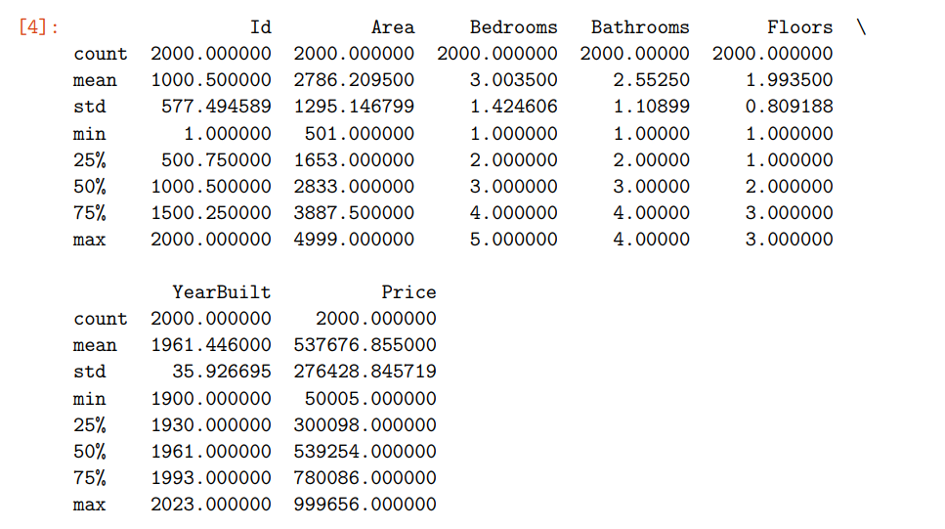

Dataset Suitability
The dataset is well-structured and suitable for applying Linear Regression due to the presence of continuous numerical variables and a clearly defined target variable. It provides sufficient data to train and test the model and to evaluate the relationship between house features and prices.

Methodology
The methodology of this mini project follows a systematic Machine Learning pipeline to predict house prices using regression techniques. Each stage of the methodology is carefully designed to ensure accurate predictions and proper evaluation of the model. The overall workflow includes data collection, preprocessing, exploratory analysis, model building, and performance evaluation.

1. Data Collection
The dataset containing historical house details is collected in CSV format and loaded into the Jupyter Notebook using the Pandas library. This dataset includes various attributes such as area, number of rooms, location, condition, and price, which are essential for predictive analysis.
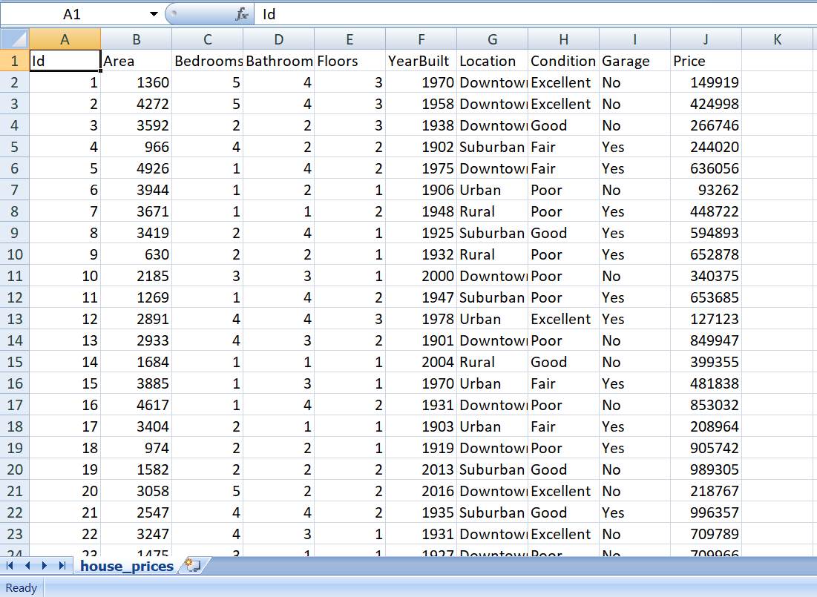

2. Data Understanding and Inspection
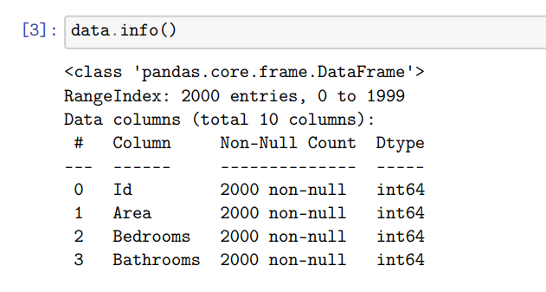
The structure of the dataset is examined using functions such as head(), info(), and describe() to understand the data types, number of records, and statistical distribution of features. This step helps in identifying numerical and categorical variables and ensures that the dataset is suitable for regression modeling.

3. Data Preprocessing
Data preprocessing is a critical step in Machine Learning. In this project, preprocessing includes:
- Handling missing values using statistical methods such as mean for numerical features and mode for categorical features
- Encoding categorical variables using One-Hot Encoding to convert them into numerical format
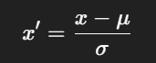
- Feature scaling using Standardization, where features are transformed using the formula:

where μ is the mean and σ is the standard deviation.
This ensures that all features contribute equally to model training.

4. Exploratory Data Analysis (EDA)
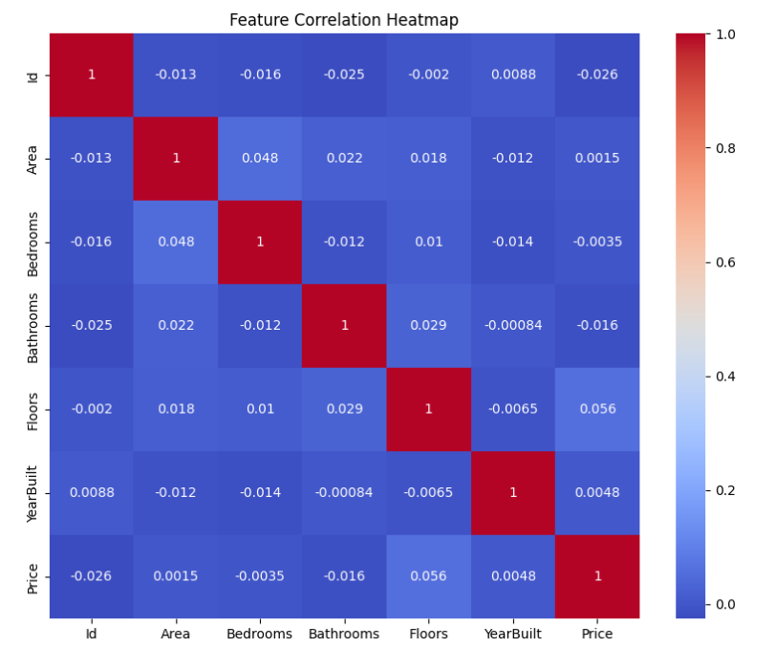
EDA is performed to analyze relationships between features and house prices. Visualization techniques such as histograms, scatter plots, and correlation heatmaps are used to identify trends, patterns, and influential variables. This step provides insights into how features affect house prices.

5. Feature Selection and Dataset Splitting
The dataset is divided into:
- Independent variables (X): House features
- Dependent variable (y): House price
The dataset is then split into training and testing sets using the train-test split method with an 80:20 ratio. This helps evaluate the model’s ability to generalize to unseen data.

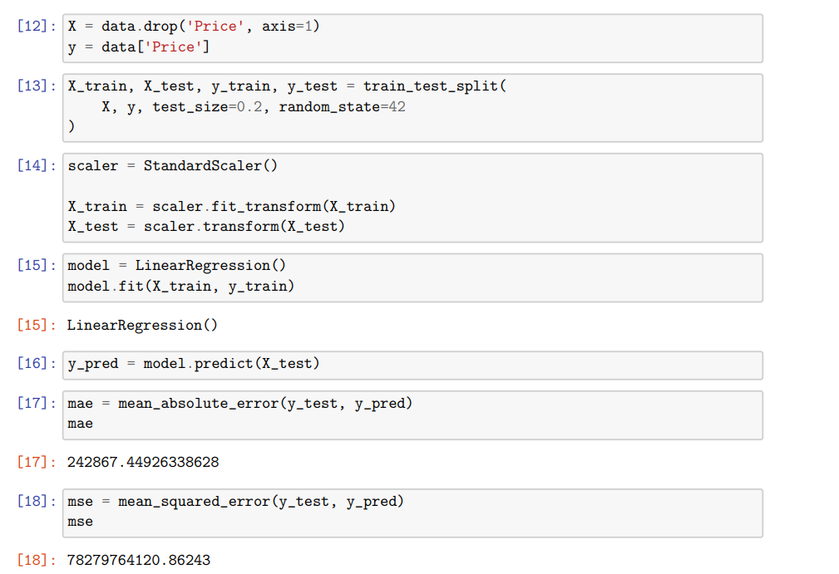

6. Model Building using Linear Regression
A Linear Regression model is implemented to learn the relationship between input features and house prices. The model is mathematically represented as:

7. Model Training
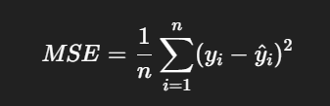
The model is trained using the training dataset. During this phase, the regression algorithm minimizes the cost function, typically Mean Squared Error (MSE), to determine optimal coefficient values:

8. Model Testing and Prediction
After training, the model is tested on the unseen test dataset. Predictions are generated for house prices, and the predicted values are compared with actual prices to assess accuracy.

9. Model Evaluation
The performance of the model is evaluated using standard regression metrics:
- Mean Absolute Error (MAE)
- Mean Squared Error (MSE)
- Root Mean Squared Error (RMSE)
- R² Score
These metrics quantify prediction errors and the goodness of fit of the model.

Data Preprocessing
Data preprocessing is a crucial step in any Machine Learning project, as the quality of input data directly affects the performance and accuracy of the model. Raw data collected from real-world sources often contains missing values, inconsistent formats, and categorical variables that are not directly suitable for Machine Learning algorithms. Therefore, preprocessing is performed to transform the raw dataset into a clean and structured format suitable for regression modeling.

1. Handling Missing Values
Missing values can negatively impact model training and prediction accuracy. In this project, the dataset is examined for missing values using null-value detection methods.
- Numerical features are handled by replacing missing values with the mean of the respective feature.
- Categorical features are handled by replacing missing values with the mode (most frequent value).
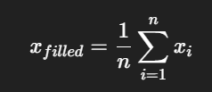
Mean imputation is represented as:

This approach maintains the statistical distribution of the data.

2. Handling Categorical Variables
Machine Learning regression algorithms require numerical input. Since attributes such as Location, Condition, and Garage are categorical, they are converted into numerical form using One-Hot Encoding.
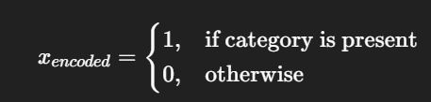
In one-hot encoding, each category is transformed into a separate binary feature:

This ensures that categorical data does not introduce unintended ordinal relationships.

3. Feature Scaling
The dataset contains features with different ranges, such as area (in square feet) and number of bedrooms. To ensure that all features contribute equally during model training, feature scaling is applied using standardization.
Standardization is performed using the formula:
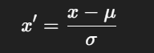

where
x= original feature value
μ= mean of the feature
σ= standard deviation of the feature
Feature scaling improves convergence speed and stability of the regression model.

4. Removing Irrelevant Features
Features that do not significantly contribute to price prediction or may introduce noise are analyzed. Although all features are retained for learning purposes in this mini project, feature relevance is assessed using correlation analysis.

5. Preparing Data for Model Training
After preprocessing, the dataset is split into:
- Input features (X)
- Target variable (y)
The clean and scaled data is then ready for training the Linear Regression model.

Importance of Data Preprocessing in Machine Learning
Proper data preprocessing:
- Improves prediction accuracy
- Reduces model bias and variance
- Ensures compatibility with Machine Learning algorithms
- Enhances model interpretability
Thus, data preprocessing forms the foundation for successful house price prediction using regression techniques.

Exploratory Data Analysis (EDA)
Exploratory Data Analysis (EDA) is an essential phase in the Machine Learning workflow that focuses on understanding the underlying structure, patterns, and relationships within the dataset before building a predictive model. EDA helps identify trends, detect anomalies, understand data distributions, and determine the influence of input features on the target variable. In this project, EDA is performed using statistical analysis and visualization techniques implemented in Python.

1. Understanding Data Distribution
The distribution of the target variable, house price, is analyzed using a histogram with a density curve. This visualization helps in understanding how house prices are spread across the dataset and whether the data is skewed or normally distributed. A balanced distribution indicates that the regression model can learn patterns effectively without bias toward extreme values.
From the visualization, it can be observed that house prices are distributed across a wide range, indicating variability in property values due to differences in features such as area, location, and condition.

2. Statistical Summary Analysis
Descriptive statistics such as mean, median, minimum, maximum, and standard deviation are computed for numerical features. This statistical summary provides insight into the central tendency and variability of features like area, number of bedrooms, and construction year. It also helps identify potential outliers and abnormal values that may affect model performance.

3. Correlation Analysis
Correlation analysis is performed to examine the strength and direction of the relationship between numerical features and house prices. A correlation heatmap is used to visualize correlation coefficients between variables.
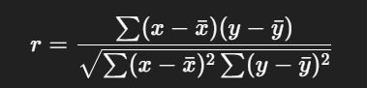
The correlation coefficient is mathematically represented as:

A positive correlation indicates that as the value of a feature increases, the house price tends to increase, while a negative correlation indicates the opposite. Features such as area and year built typically show a positive correlation with house price.

4. Feature Relationship Analysis
Scatter plots are used to analyze the relationship between key input features and the target variable. For example, a scatter plot between area and price shows that larger houses generally have higher prices. This observation supports the assumption of a linear relationship, making Linear Regression a suitable choice for this project.

5. Detection of Multicollinearity
EDA also helps identify multicollinearity, where two or more independent variables are highly correlated with each other. High multicollinearity can negatively affect regression coefficients. Correlation analysis is used to detect such issues and ensure model reliability.

6. Importance of EDA in Machine Learning
EDA plays a critical role in:
- Selecting relevant features
- Understanding data behavior
- Choosing an appropriate Machine Learning model
- Improving prediction accuracy
By performing EDA, meaningful insights are obtained, which guide the preprocessing and modeling stages of the house price prediction system.

Regression Models Used
Regression is a supervised Machine Learning technique used to predict a continuous output variable based on one or more input features. In this mini project, regression models are used to learn the relationship between house features such as area, number of rooms, location, and condition, and the corresponding house prices.

1. Linear Regression
The primary regression model used in this project is Linear Regression. It is one of the most fundamental and widely used regression algorithms in Machine Learning. Linear Regression assumes a linear relationship between independent variables and the dependent variable.
The mathematical representation of Linear Regression is:

where:
y = predicted house price
x1,x2,…,xn = input features (area, bedrooms, location, etc.)
β0 = intercept
β1,β2,…,βn= regression coefficients
The objective of Linear Regression is to determine the optimal values of coefficients that minimize the prediction error.

2. Cost Function
To measure prediction error, Linear Regression uses a cost function, commonly the Mean Squared Error (MSE):
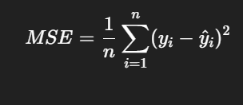

The model aims to minimize this cost function during training.

3. Training Mechanism
During training, the model learns coefficient values that best fit the data. Scikit-learn internally uses optimization techniques such as Ordinary Least Squares (OLS) to compute the coefficients efficiently.

4. Suitability of Linear Regression
Linear Regression is chosen for this mini project because:
- The target variable (house price) is continuous
- The relationship between features and price shows linear trends
- The model is simple, interpretable, and suitable for academic projects
- It allows easy analysis of feature influence using coefficients

5. Interpretation of Regression Coefficients
Each regression coefficient represents the expected change in house price for a unit change in the corresponding feature, while keeping other features constant. Positive coefficients indicate an increase in price, while negative coefficients indicate a decrease.

Conclusion on Regression Model Selection
Linear Regression provides a strong foundation for understanding predictive modeling and serves as an effective regression technique for house price prediction in an academic setting. It also helps students interpret results and understand the impact of various features on house prices.

Model Training and Testing
Model training and testing is a crucial stage in the Machine Learning workflow, where the regression model learns patterns from historical data and is evaluated on unseen data. This process ensures that the model not only fits the training data but also generalizes well to new inputs.

1. Splitting the Dataset
After data preprocessing and feature encoding, the dataset is divided into two parts:
- Training dataset
- Testing dataset
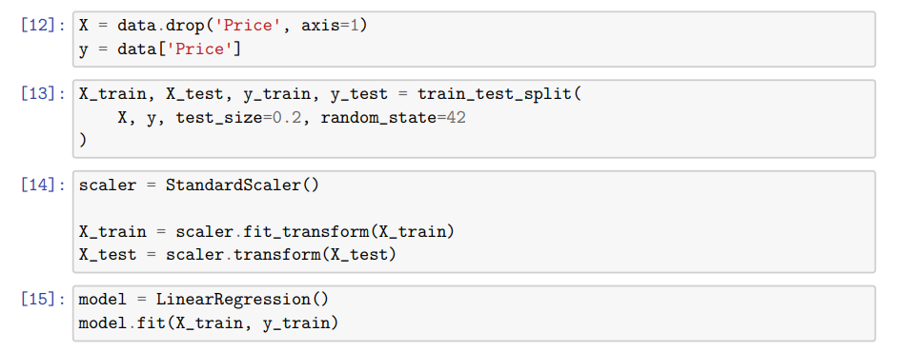
In this project, the dataset is split using an 80:20 ratio, where 80% of the data is used for training the model and 20% is reserved for testing. This split is performed using the train_test_split() function from the Scikit-learn library. The purpose of this split is to evaluate the model’s predictive ability on unseen data and prevent overfitting.

2. Feature Scaling
Before training the model, feature scaling is applied to ensure that all input features are on a similar scale. Since features such as area and year built have different value ranges, standardization is used to normalize the data.
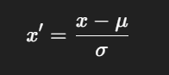
The standardization formula is given by:

where:
x = original feature value
μ = mean of the feature
σ= standard deviation of the feature
Feature scaling improves the stability and convergence of the regression model during training.

3. Model Training
The Linear Regression model is trained using the training dataset. During this phase, the algorithm learns the optimal values of regression coefficients by minimizing the Mean Squared Error (MSE) between actual and predicted house prices.
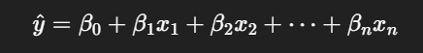
The learning process is mathematically represented as:

The Scikit-learn implementation internally uses Ordinary Least Squares (OLS) to estimate coefficient values efficiently.

4. Model Testing
Once the model is trained, it is evaluated using the testing dataset. The trained model predicts house prices for the test data, which were not used during training. These predicted values are then compared with the actual house prices to measure the model’s accuracy and reliability.

5. Importance of Training and Testing
Separating training and testing data is essential to:
- Avoid overfitting
- Evaluate generalization performance
- Measure real-world prediction capability
A well-trained model should perform consistently on both training and testing datasets.

Conclusion
Through proper dataset splitting, feature scaling, and model training, the regression model is prepared to make accurate predictions. The testing phase validates the effectiveness of the model and ensures that it meets the objectives of the house price prediction system.

Performance Evaluation Metrics
Performance evaluation metrics are used to measure the accuracy and effectiveness of the regression model. Since house price prediction is a regression problem with a continuous output variable, appropriate error-based and statistical metrics are used to evaluate model performance. These metrics compare the actual house prices with the predicted house prices generated by the model.

1. Mean Absolute Error (MAE)
Mean Absolute Error measures the average magnitude of errors between predicted and actual values, without considering their direction.
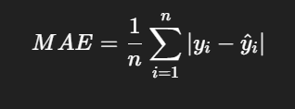

A lower MAE value indicates better prediction accuracy.

2. Mean Squared Error (MSE)
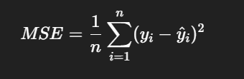
Mean Squared Error measures the average of squared differences between actual and predicted values. Squaring penalizes larger errors more heavily.

MSE is sensitive to outliers and helps detect large prediction errors.

3. Root Mean Squared Error (RMSE)

Root Mean Squared Error is the square root of MSE and provides error values in the same unit as the target variable (house price).

RMSE gives a clearer interpretation of average prediction error.

4. R-squared (R²) Score
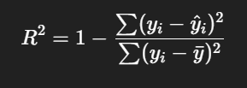
The R² score measures how well the independent variables explain the variance in the dependent variable.

R² values range from 0 to 1. A higher R² score indicates better model fit. A negative R² indicates poor model performance.

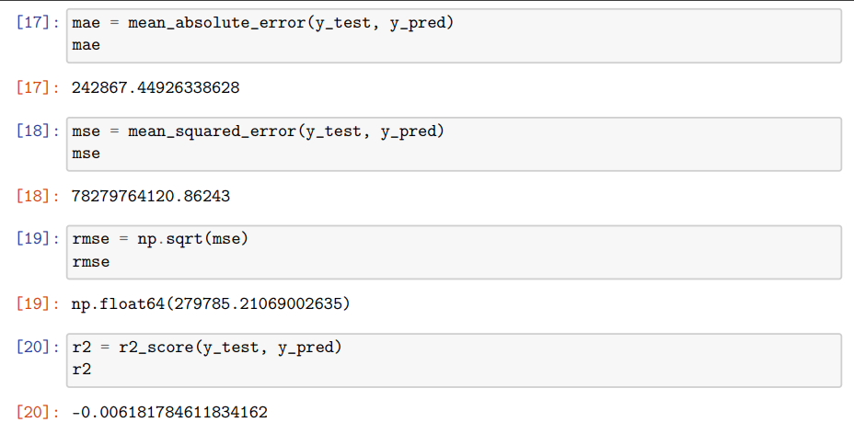

Importance of Evaluation Metrics
Using multiple metrics provides a comprehensive understanding of model performance:
- MAE indicates average prediction error
- MSE and RMSE highlight large errors
- R² measures overall goodness of fit
These metrics together help assess the reliability and accuracy of the house price prediction model.

Results and Discussion
After training the Linear Regression model using the preprocessed housing dataset, the model was evaluated on the testing dataset to assess its prediction performance. The results obtained provide insights into the accuracy of the model and the influence of various features on house prices.

1. Prediction Results
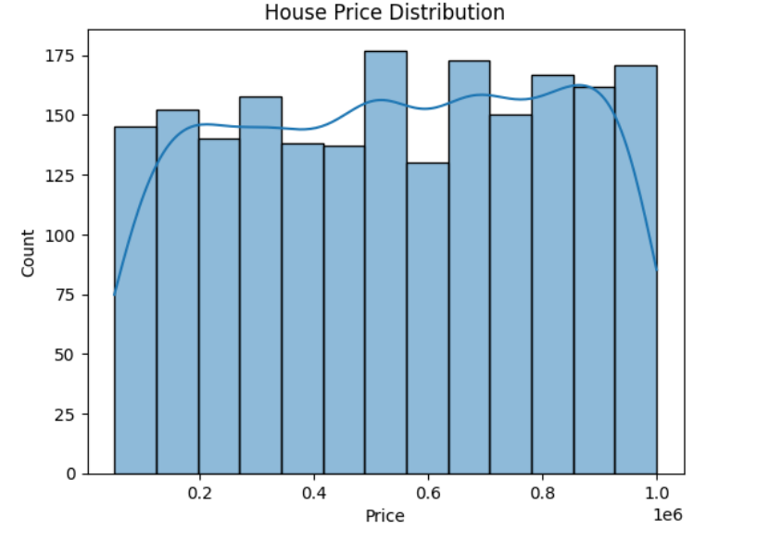
The trained regression model generated predicted house prices for the test dataset. These predicted values were compared with the actual house prices to evaluate model performance. A scatter plot between actual and predicted prices was used to visually assess prediction accuracy. Ideally, the points should lie close to the diagonal line, indicating accurate predictions. The observed scatter shows a moderate deviation, suggesting that the model captures general trends but has room for improvement.

2. Evaluation Metric Analysis
The performance of the model was evaluated using standard regression metrics:
- Mean Absolute Error (MAE) represents the average absolute difference between actual and predicted prices. The obtained MAE value indicates that the model predictions deviate from actual prices by a considerable margin on average.
- Mean Squared Error (MSE) penalizes large errors more strongly and reflects the variance of prediction errors.
- Root Mean Squared Error (RMSE) provides an interpretable error measure in the same unit as house prices.
- R² Score measures the goodness of fit of the model. The obtained R² value indicates that the model explains only a small portion of the variance in house prices, suggesting that the linear relationship between features and price is limited for this dataset.
These results indicate that while the model learns certain patterns, it does not fully capture the complexity of house price prediction.

3. Feature Influence Analysis
Regression coefficients were analyzed to understand the impact of each feature on house price prediction. Features such as number of floors, year built, and property condition showed a positive influence on price, indicating that houses with better conditions and newer construction tend to have higher prices. Some features showed negative coefficients, which may be due to multicollinearity, feature scaling, or interactions among variables.
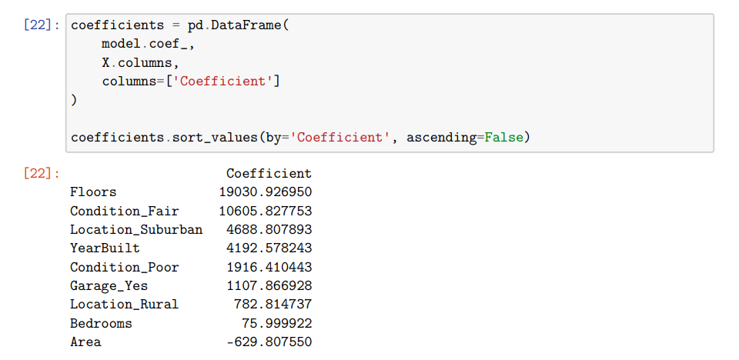

4. Discussion
The results demonstrate that Linear Regression provides a basic understanding of how house features influence prices. However, the relatively low prediction accuracy suggests that house prices are influenced by complex, nonlinear relationships that cannot be fully captured by a simple linear model. Factors such as location desirability, market demand, and economic conditions may also play a significant role but are not fully represented in the dataset.
Despite these limitations, the project successfully achieves its academic objective of demonstrating the complete Machine Learning workflow, including data preprocessing, exploratory data analysis, regression modeling, and evaluation.

Conclusion of Results
Overall, the Linear Regression model serves as an effective baseline for house price prediction and provides valuable insights into feature relationships. The results highlight the importance of advanced modeling techniques and feature engineering for improving prediction accuracy in future work.

Advantages of the System
The house price prediction system developed using Machine Learning regression techniques offers several advantages over traditional manual estimation methods. The key advantages of the system are as follows:

1. Automated Price Prediction
The system automatically predicts house prices based on input features such as area, number of rooms, location, and condition. This reduces dependency on manual analysis and expert judgment.

2. Data-Driven Decision Making
The model makes predictions based on historical data and learned patterns, ensuring objective and consistent results. This data-driven approach minimizes human bias in pricing decisions.

3. Time and Cost Efficient
Once trained, the regression model can predict prices instantly, saving time and effort compared to traditional valuation methods that require extensive market analysis.

4. Interpretability of Results
Linear Regression provides clear interpretability through regression coefficients, allowing users to understand how each feature influences house prices. This is especially useful for academic learning and analysis.

5. Scalability
The system can handle large datasets and can be easily updated with new data to improve prediction performance without changing the underlying methodology.

6. Practical Learning Experience
The project provides hands-on experience with Machine Learning concepts such as data preprocessing, feature scaling, model training, and evaluation, making it highly beneficial for students.

7. Reusable and Extendable
The developed system can be extended to include advanced regression models or integrated into real-world applications such as real estate platforms

Limitations of the System
Although the house price prediction system demonstrates the application of Machine Learning regression techniques, it has certain limitations that affect prediction accuracy and real-world applicability. These limitations are outlined below:

1. Assumption of Linear Relationship
The system is based on Linear Regression, which assumes a linear relationship between input features and house prices. In reality, property prices are often influenced by complex and nonlinear factors that the model cannot fully capture.

2. Dependency on Dataset Quality
The accuracy of the prediction model heavily depends on the quality, size, and representativeness of the dataset. Any bias, noise, or missing influential factors in the dataset can negatively impact model performance.

3. Limited Feature Set
The model considers only a limited number of features such as area, rooms, and location. Important real-world factors like economic conditions, market demand, interest rates, neighborhood development, and legal aspects are not included.

4. Low Generalization Capability
The model may not generalize well to different geographical regions or time periods, especially if market conditions change significantly from the training data.

5. Sensitivity to Outliers
Linear Regression is sensitive to outliers, which can significantly affect regression coefficients and prediction accuracy if not handled properly.

6. No Real-Time Data Integration
The system uses static historical data and does not incorporate real-time property listings or market trends, limiting its applicability in dynamic real estate environments.

Summary of Limitations
While the system effectively demonstrates the Machine Learning workflow for academic purposes, these limitations highlight the need for advanced models, additional features, and real-time data integration to improve accuracy and robustness.

Applications of House Price Prediction
House price prediction systems developed using Machine Learning regression techniques have a wide range of applications in the real world. By analyzing historical housing data and learning relationships between various features and prices, such systems provide valuable insights and support informed decision-making. Some major applications are discussed below:

1. Real Estate Platforms
Online real estate websites can use house price prediction models to display estimated property values. This helps users compare prices, identify fair market value, and make better buying or selling decisions.

2. Property Investment Analysis
Investors can use prediction systems to evaluate potential returns on investment. By estimating future property prices, investors can identify profitable locations and properties.

3. Decision Support for Buyers and Sellers
Buyers can use predicted prices to avoid overpaying for properties, while sellers can determine competitive pricing strategies based on data-driven insights rather than assumptions.

4. Urban Planning and Development
Government agencies and urban planners can analyze housing trends to understand property value distribution across regions. This supports infrastructure planning, taxation policies, and housing development strategies.

5. Banking and Financial Institutions
Banks and financial organizations can use house price prediction models to assist in property valuation during loan approval, mortgage assessment, and risk analysis.

6. Academic and Research Purposes
House price prediction serves as a common benchmark problem in Machine Learning education. It helps students and researchers understand regression techniques, data preprocessing, and model evaluation.

7. Market Trend Analysis
Analyzing predicted prices over time helps identify real estate market trends, price growth patterns, and high-demand areas.

Summary : House price prediction systems provide practical value across multiple domains by enabling accurate, efficient, and data-driven estimation of property values. These applications highlight the importance of Machine Learning in solving real-world problems.

Conclusion
This mini project successfully demonstrates the application of Machine Learning regression techniques for predicting house prices using historical housing data. By implementing a Linear Regression model, the project highlights how supervised learning algorithms can be used to analyze relationships between various house features and their corresponding prices.
The project followed a systematic Machine Learning workflow that included data collection, preprocessing, exploratory data analysis, feature encoding, model training, testing, and performance evaluation. Python and Jupyter Notebook were effectively used to implement and visualize each stage of the process. Evaluation metrics such as MAE, MSE, RMSE, and R² score were used to assess model performance and understand prediction accuracy.
Although the Linear Regression model provided a basic understanding of price prediction and feature influence, the results also revealed certain limitations in capturing complex and nonlinear relationships present in real-world real estate data. Nevertheless, the project achieved its academic objectives by providing practical exposure to Machine Learning concepts and reinforcing theoretical knowledge through hands-on implementation.
Overall, this project serves as a strong foundation for understanding regression-based prediction systems and demonstrates the potential of Machine Learning techniques in solving real-world problems. It also provides scope for future enhancement using advanced models and real-time data integration.

Future Enhancements
Although the current house price prediction system using Linear Regression fulfills the academic objectives of this mini project, several enhancements can be made to improve its accuracy, scalability, and real-world usability. The following enhancements can be considered in future work:

1. Use of Advanced Machine Learning Models
More advanced regression models such as Ridge Regression, Lasso Regression, Decision Tree Regression, Random Forest Regression, and Gradient Boosting can be implemented to capture complex and nonlinear relationships between features and house prices.

2. Improved Feature Engineering
Additional features such as proximity to schools, hospitals, public transport, neighborhood ratings, and crime rates can be included. Feature engineering techniques can be applied to create new meaningful variables that enhance model performance.

3. Hyperparameter Tuning
Model performance can be improved by applying hyperparameter tuning techniques such as Grid Search or Random Search to identify optimal model parameters.

4. Handling Outliers and Noise
Advanced outlier detection and noise reduction techniques can be used to minimize the impact of extreme values on prediction accuracy.

5. Real-Time Data Integration
The system can be enhanced by integrating real-time housing data from online real estate platforms to reflect current market trends and dynamic pricing.

6. Model Deployment
The trained model can be deployed as a web application or API using frameworks such as Flask or Django, allowing users to input house details and receive instant price predictions.

7. Model Performance Monitoring
Continuous monitoring and retraining of the model with updated data can help maintain accuracy and reliability over time.

Summary
These future enhancements can significantly improve the robustness and practical applicability of the house price prediction system. Incorporating advanced Machine Learning techniques and real-time data will make the system more accurate and suitable for real-world deployment beyond academic use.

References
- Tom M. Mitchell, Machine Learning, McGraw-Hill Education, 1997.
- Ian Goodfellow, Yoshua Bengio, and Aaron Courville, Deep Learning, MIT Press, 2016.
- Aurélien Géron, Hands-On Machine Learning with Scikit-Learn, Keras & TensorFlow, O’Reilly Media.
- Scikit-learn Documentation – Machine Learning in Python.
- Pandas Documentation – Data Analysis and Manipulation Tool.
- NumPy Documentation – Scientific Computing with Python.
- Matplotlib Documentation – Visualization Library for Python.
- Seaborn Documentation – Statistical Data Visualization in Python.
- Research articles on House Price Prediction using Regression Techniques. (Reddit)
- Online datasets and academic resources related to real estate price analysis.(Kaggle,github,gitkraken,git)

Department of Bachelor of Computer Applications

KALPATARU FIRST GRADE SCIENCE COLLEGE

(A Unit of Kalpataru Vidya Samsthe ®)

Affiliated to Tumkur University and Reaccredited with A grade from NAAC

Tiptur (t),Tumkur (d) – 572201


DECLARATION
We hereby declare that the project work entitled "[Insert Project Title Here]" is a bonafide work carried out by our team under the guidance of Mr. Ravikiran S J and Mr. Omkar K P, in partial fulfillment of the requirements for the award of the degree of Bachelor of Computer Applications (BCA) in Data Science prescribed by Tumkur University.
All the information, data, results, and conclusions presented in this project are true to the best of our knowledge and belief. All sources of information used in this project have been properly acknowledged.

Team Members Details:

Course / Semester: ______________________________
Department: ______________________________
Institution Name: ______________________________
Place: ______________________________
Date: ______________________________

GUIDE(S) DECLARATION
We hereby certify that the above declaration made by the students is correct and that the project work was carried out under our guidance.
Mr. Ravikiran S J Designation: ______________________________
Department: ______________________________
Signature: ______________________________
Mr. Omkar K P Designation: ______________________________
Department: ______________________________
Signature: ______________________________

HEAD OF THE DEPARTMENT
Name: ______________________________
Designation: Head of the Department
Department: ______________________________
Signature: ______________________________

